**Choosing Appropriate Statistical Analyses**

**DVs: Number of Trips and Visitors**

##Matrix Correlation observation:

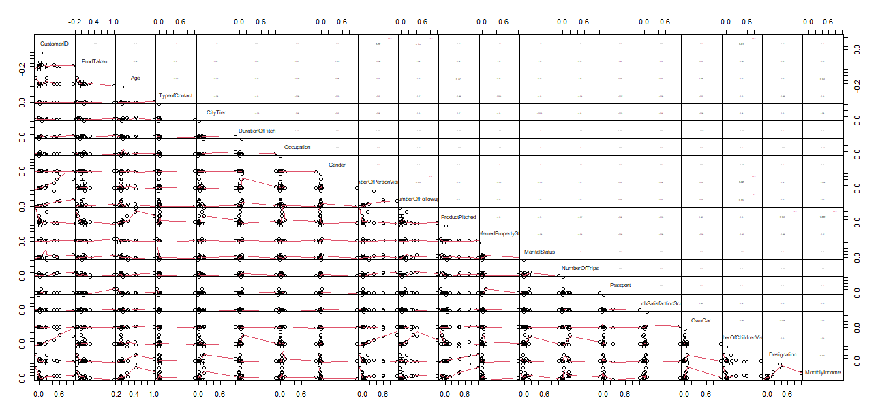

Correlation with customer who bought a product and make under 10 trips

Correlation with all customers.

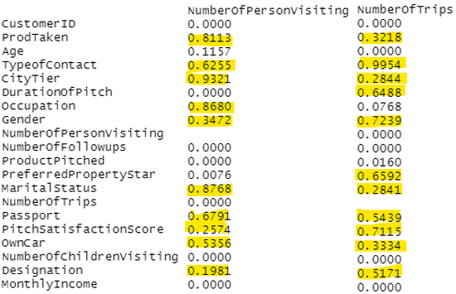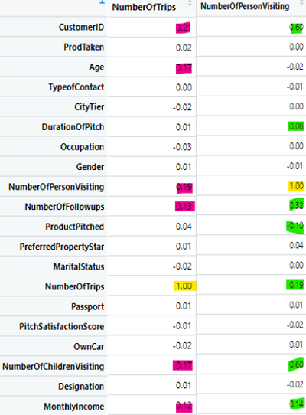

* As we can see, the correlation in the original dataset is very week since 80% of our customer base did not make a purchase.
* Therefore, we would more likely gather more realistic information on customers who are interesting in our product if we only exam customers who actually made a purchase.
* In addition, most customer made under 10 trips. Therefore, we will also not exam those exceptions in our analysis.

According to our matrix table, there are variables that highly correlated with both of our DVs and few only correlated with one of our DVs. We will exam these correlations in details.

#DVs: NumberOfTrips and NumberOfPersonVisiting

Categorical IVs correlated with both DVs: - **MANOVA**

TypeofContact

CityTier

Gender

MaritalStatus

Passport

OwnCar

Designation   
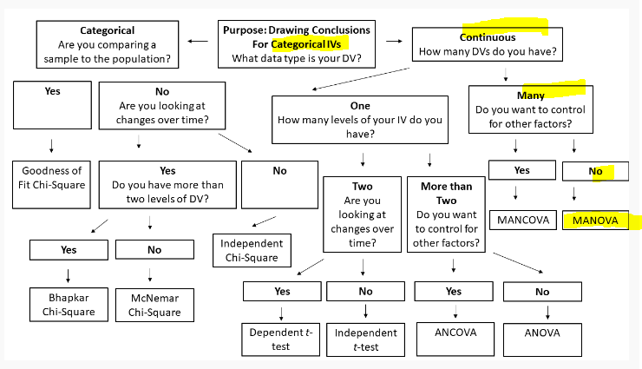

TypeofContact

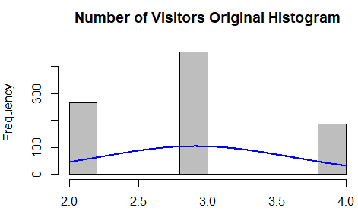 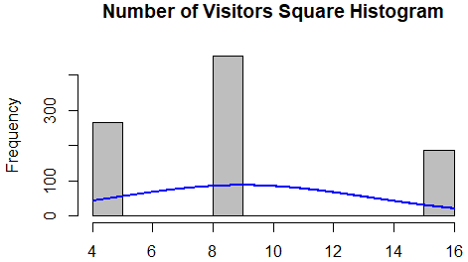

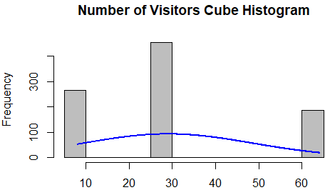 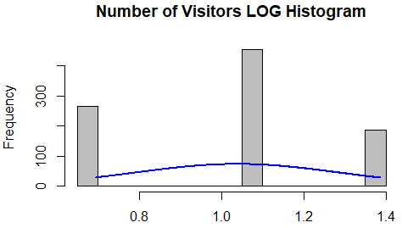

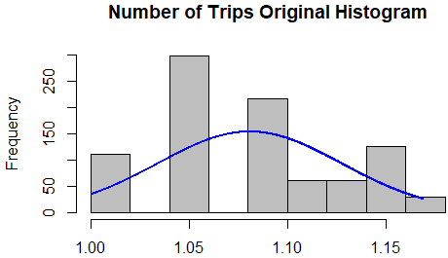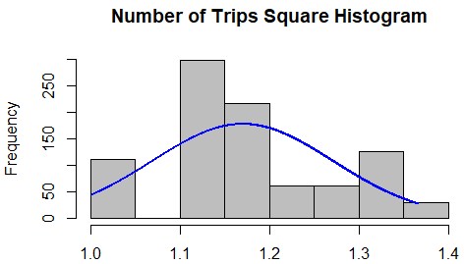

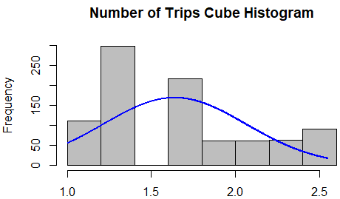 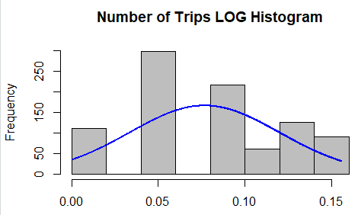

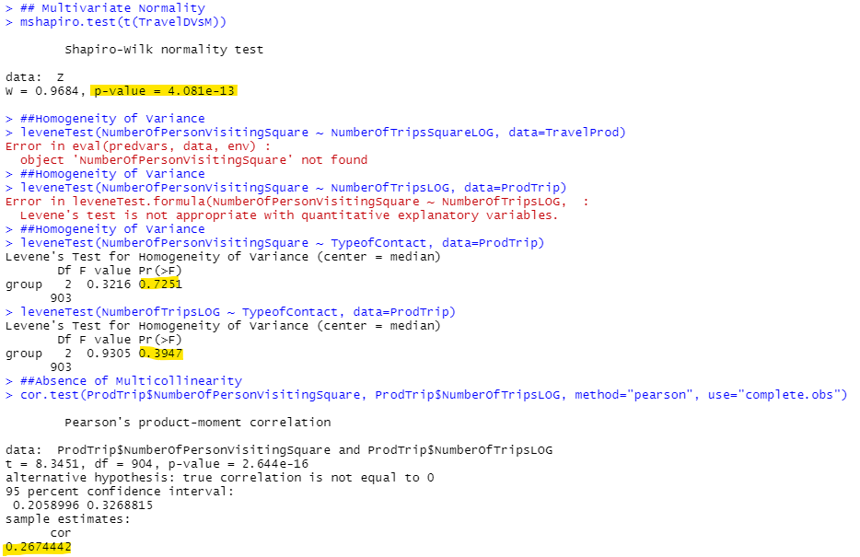

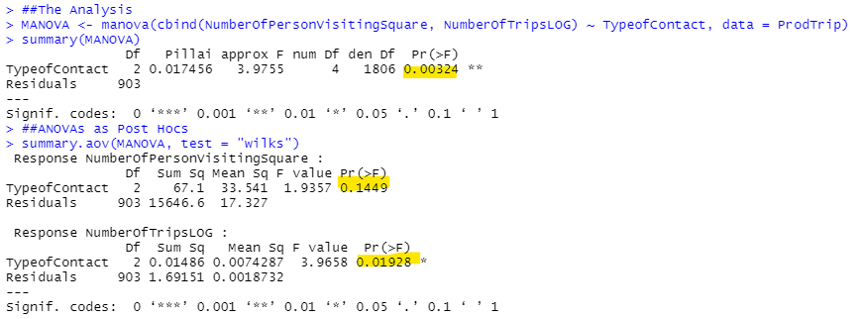

CityTier

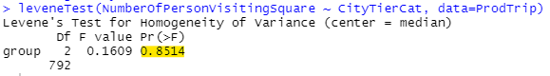

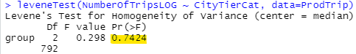

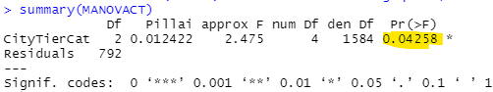

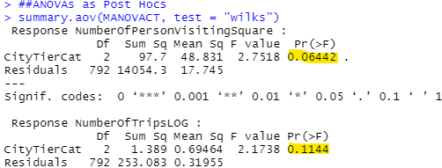

Gender

